**PART IV: GOVERNANCE**

1. **Democracy: Explore referendum-related activities.**

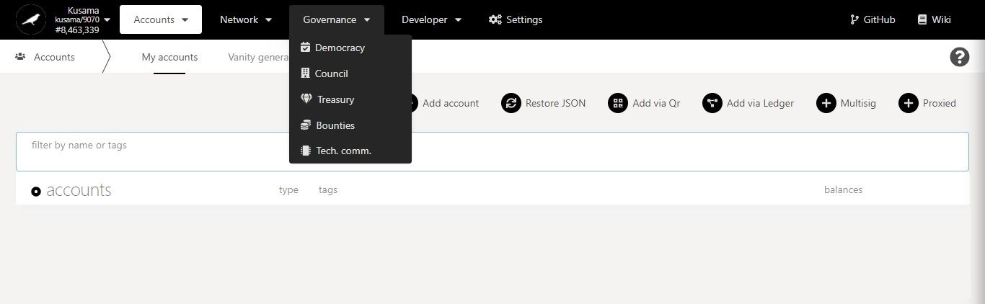

**Basic information on technical words** used in the DEMOCRACY section.

* 1. **Vote for referenda.**

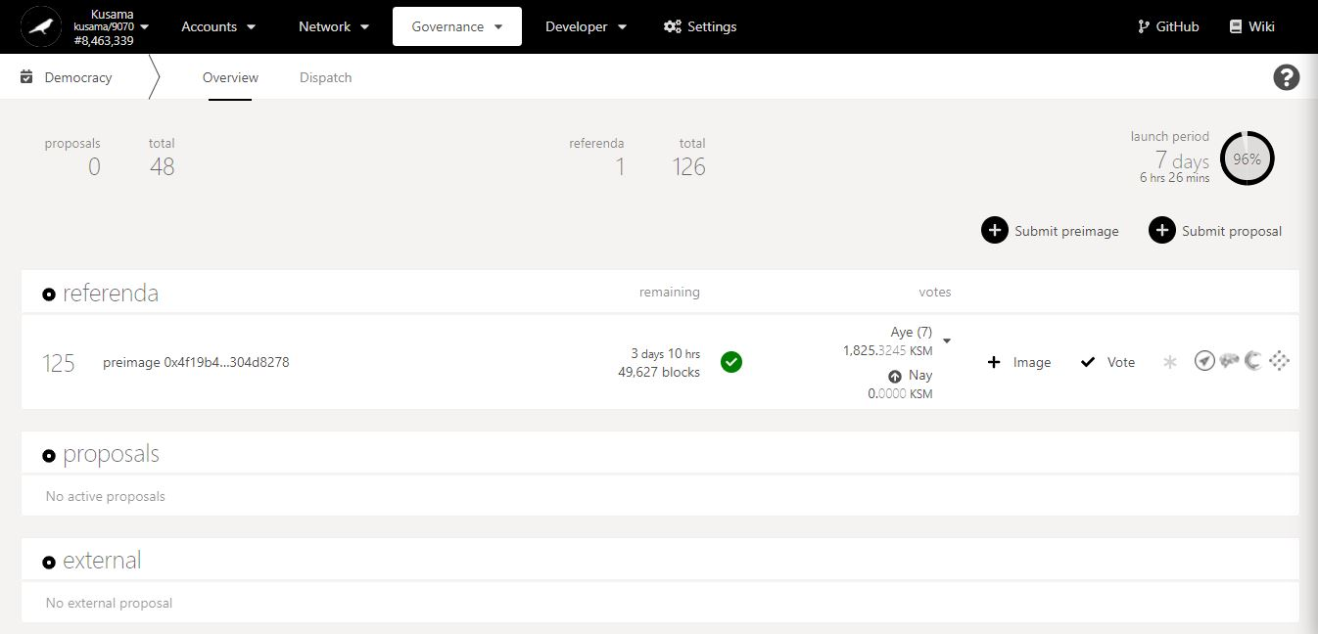

1. Click on the ***Polkassembly* icon** to view the discussion thread.

Key information on democracy: **number of proposals, number of referenda, and time left before a new referendum can be launched.**

Countdown to **the end of the voting period.**

Referendum **ID.**

Referendum **turnout**

Referendum **status (PASS or FAIL)**

Referendum-related **external links**.

Referendum **pre-image hash**.

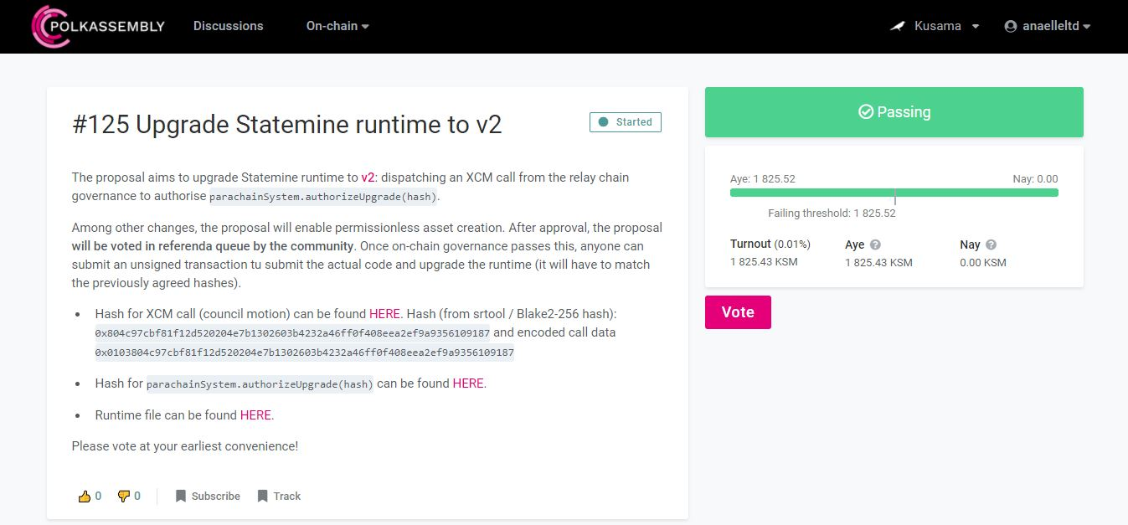

3. If you are registered on *Polkassembly*, you can click on **vote** to complete the procedure. Otherwise, **go back to *Polkadot-JS Apps***.

2. Read the **information on the referendum**.



4. Click on **vote**.

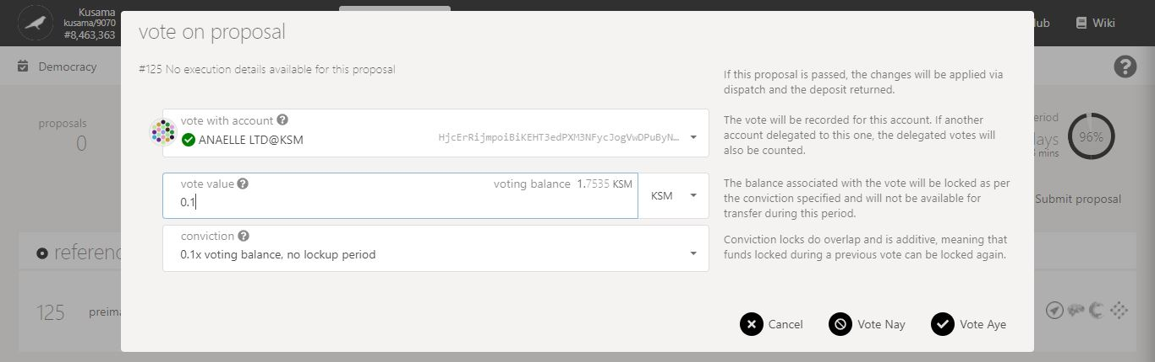

7. Click on the **dropdown arrow** to view more conviction setups.

6. Enter a KSM amount **for your vote.**

5. Follow **on-screen instructions** carefully.

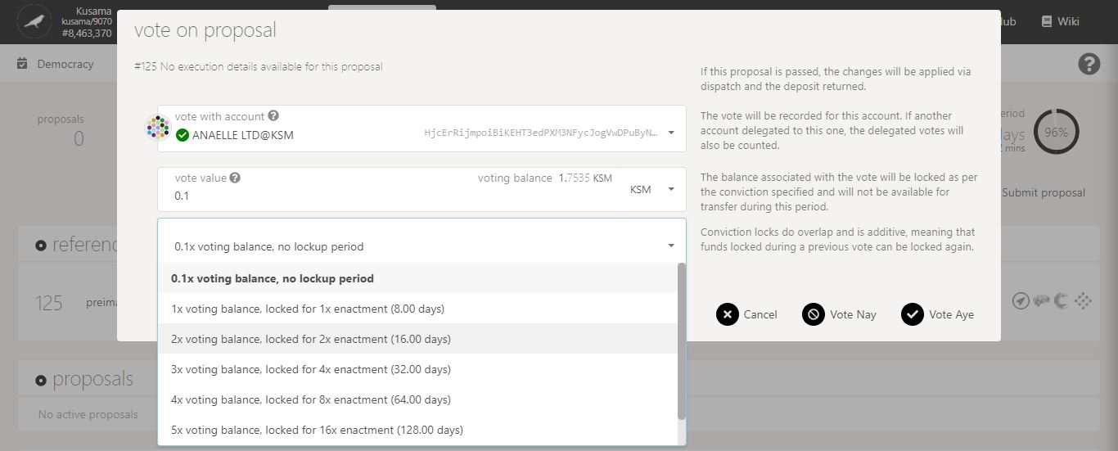

8. Select **one conviction setup** for your vote**.** Note: KSM balances locked through democracy votes must be unlocked at the end of the lockup period to become transferrable.

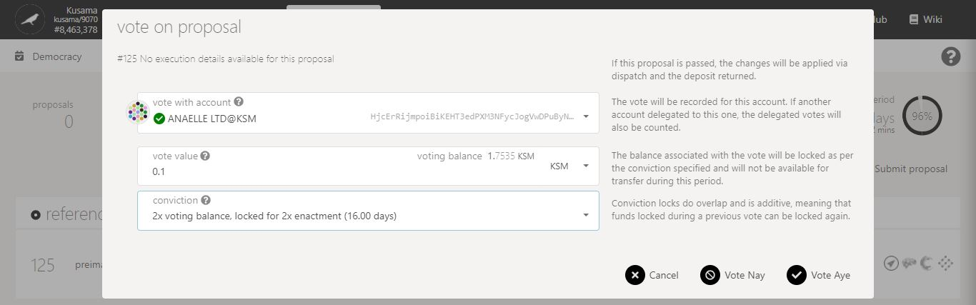

9. Click on **Vote Nay** or **Vote Aye** to continue the procedure.

**Nature** of the transaction.

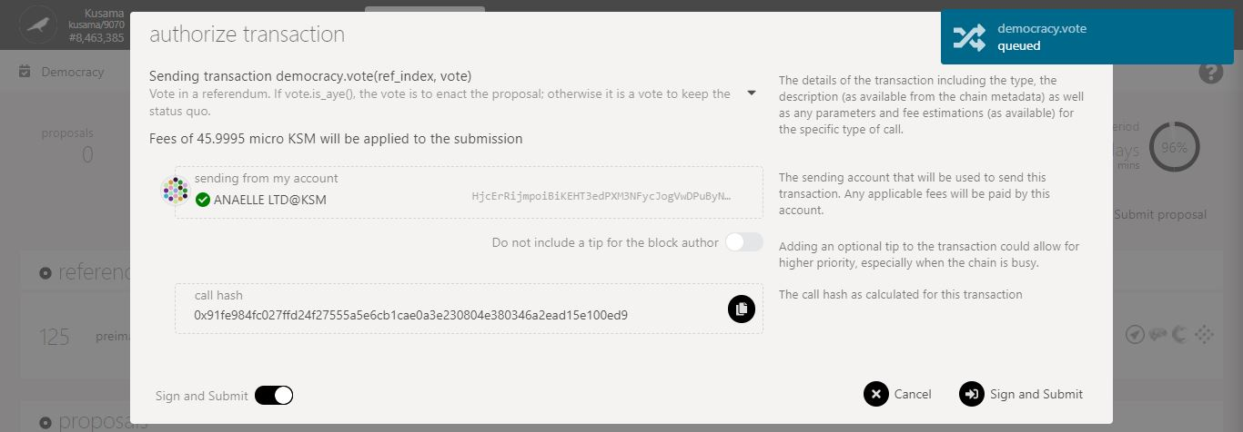

11. Click on **Sign & submit** to continue the procedure.

10. Check the **transaction fees**.

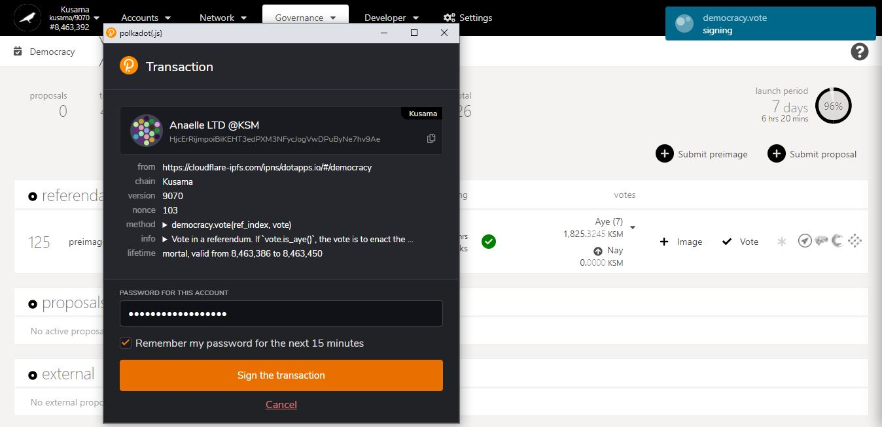

**Summary** of the transaction sent via the Polkadot-JS extension.

**Progress** of the transaction.

12. Enter **your account’s password** and tick the box to **remember your password, if necessary**.

13. Click on **Sign the transaction** to complete the procedure.

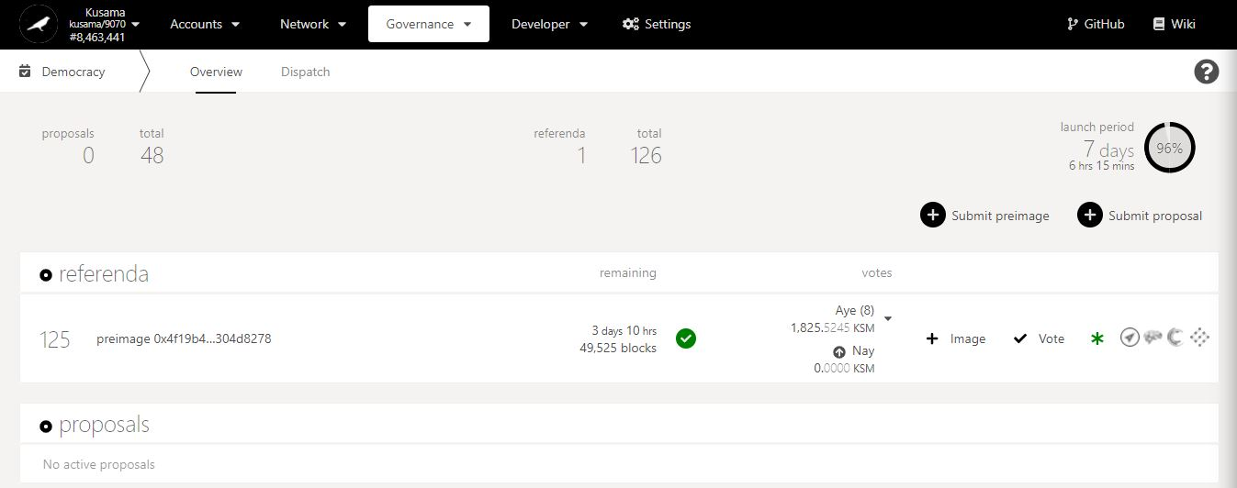

14. **Your vote has been included!**

15. Click on the **dropdown arrow** to view your voting details.

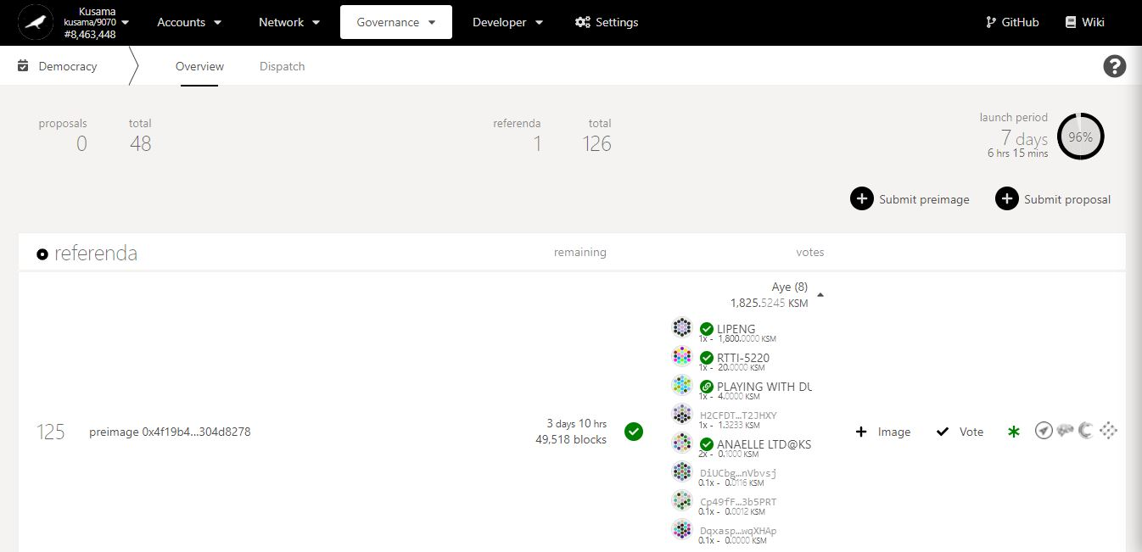

16. **Your account address, lockup period and voting amount are displayed!**

* 1. **Clear expired democracy locks.**

1. Click **Accounts**.

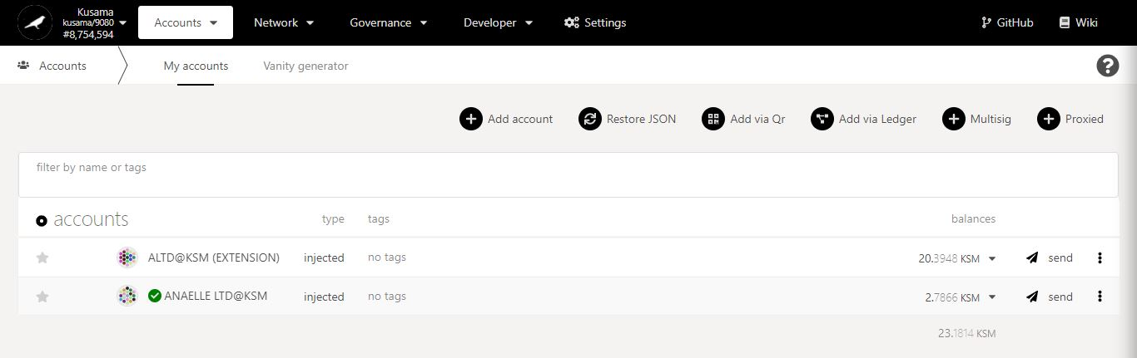

2. Click on the **dropdown arrow** to view your balances.

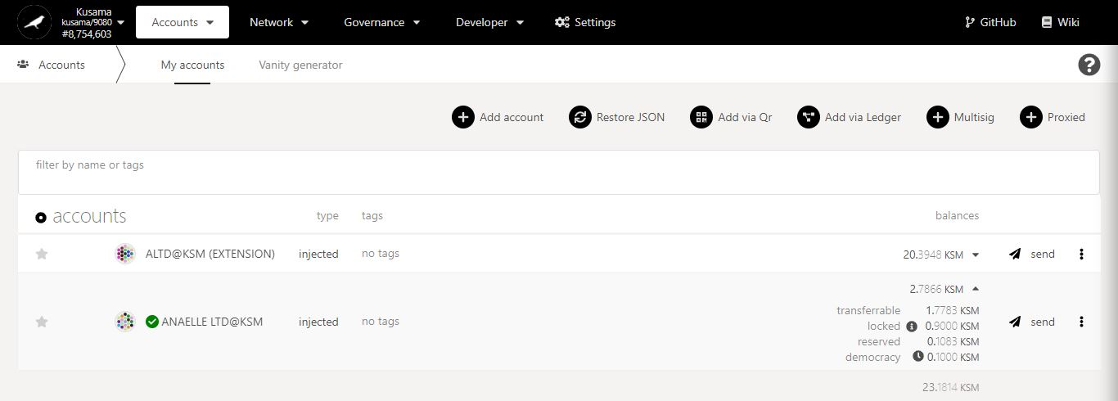

3. **Your democracy balance is now visible!**

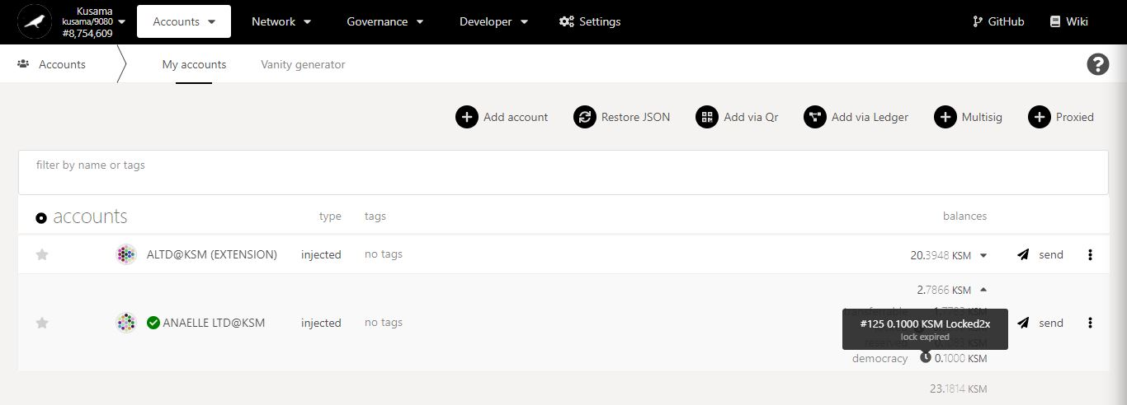

5. Click on the 3 vertical dots to view **Account settings**.

4. Hover on the **icon** to check the lock status.

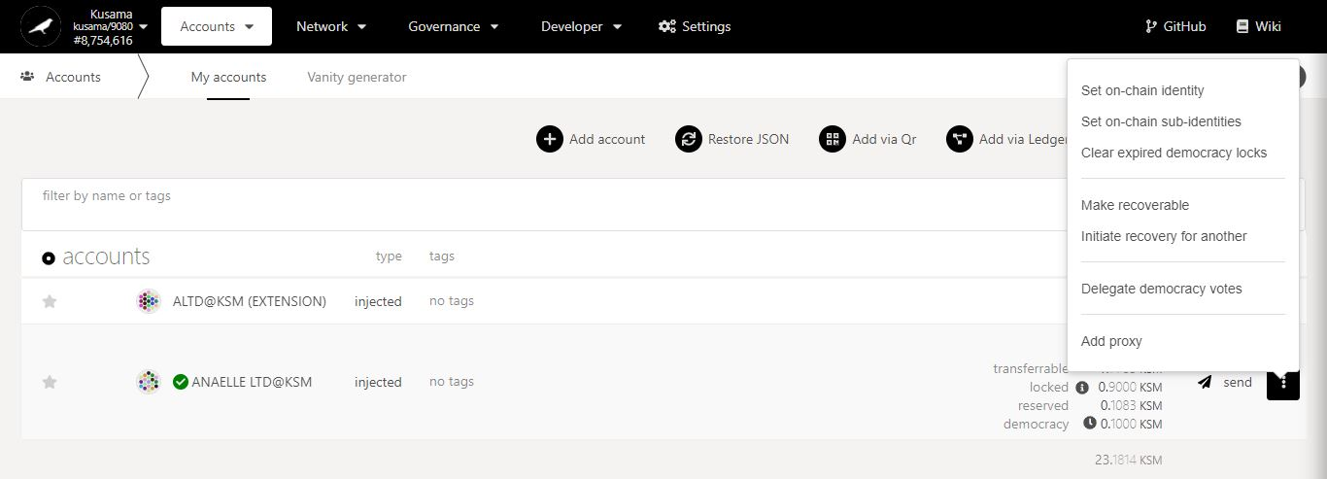

6. Click on **Clear expired democracy locks** to remove your votes.

**Nature** of the transaction.

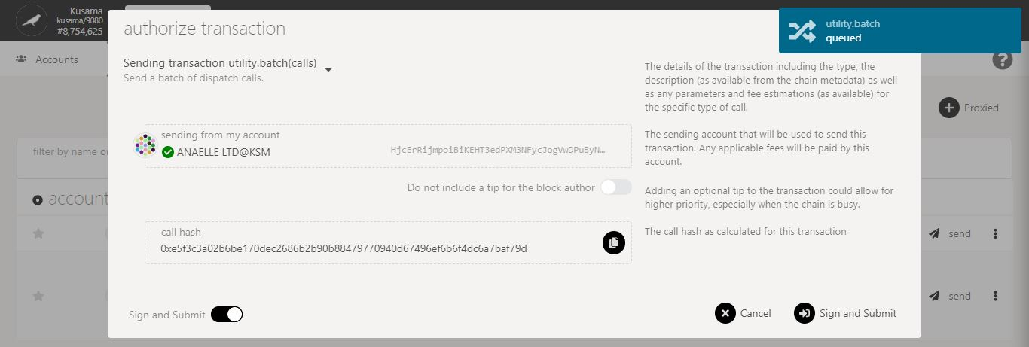

7. Click on **Sign & submit** to continue the procedure.

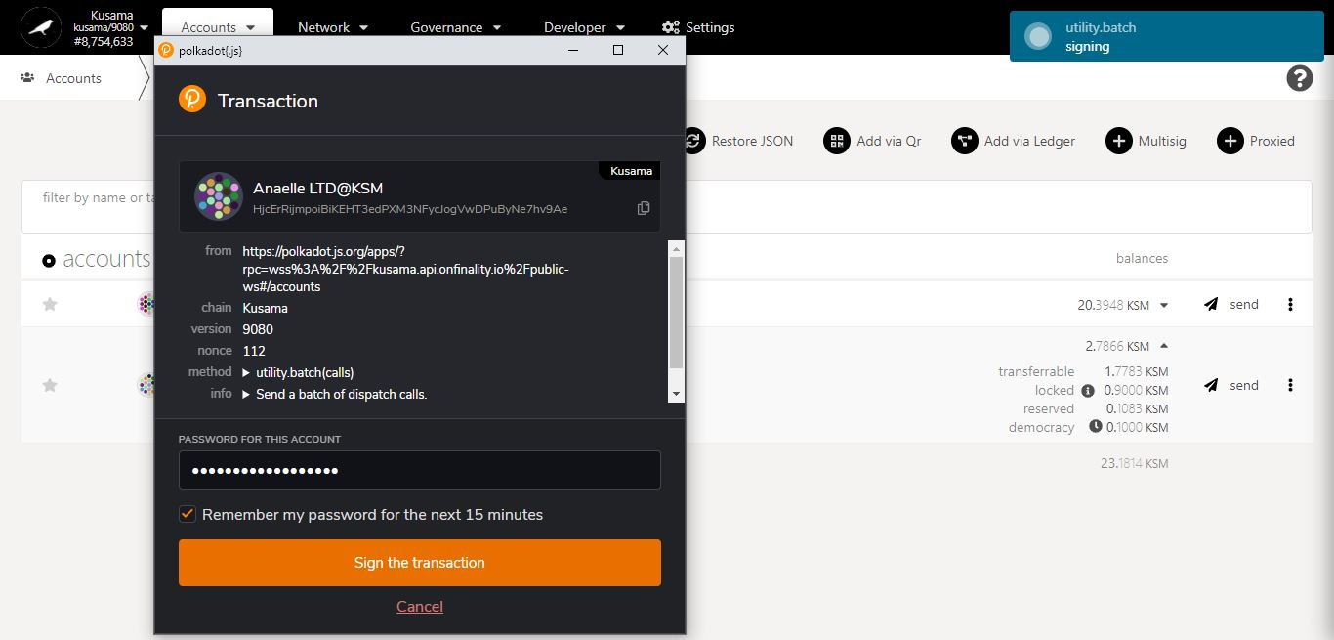

8. Enter **your account’s password** and tick the box to **remember your password, if necessary**.

**Progress** of the transaction.

9. Click on **Sign the transaction** to complete the procedure.

**Summary** of the transaction sent via the Polkadot-JS extension.

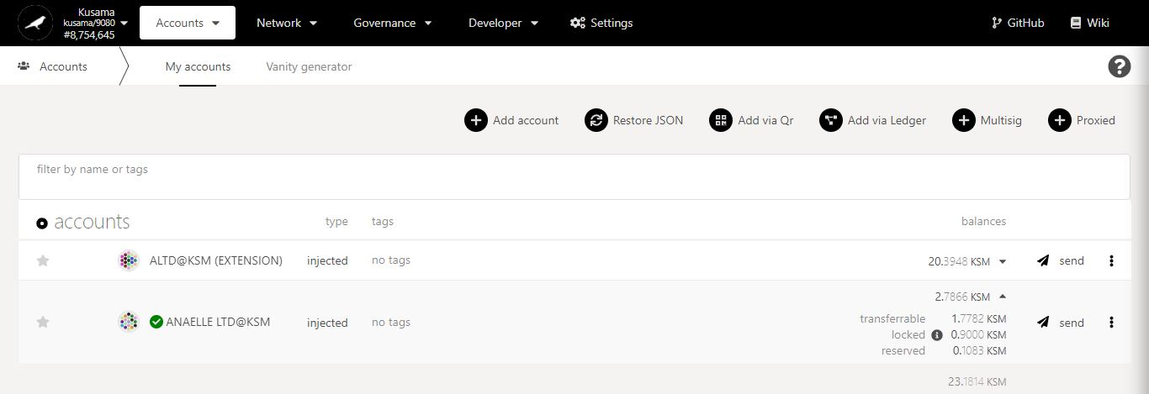

10. **Your democracy locks have been cleared!**

* 1. **Submit referendum pre-images.**

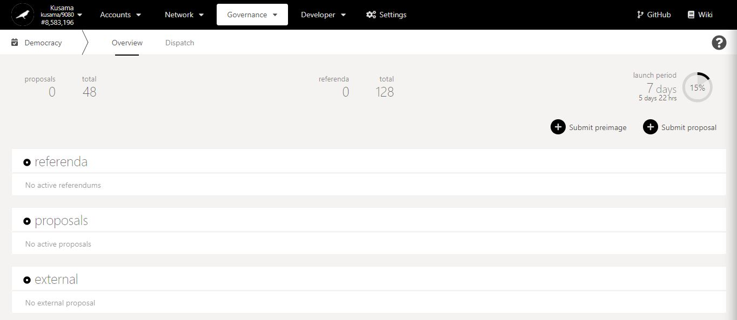

Referendum preimage in detail:

A **referendum preimage** is the first of two steps when proposing a public referendum that the community can vote on.

The preimage hash is required to enact/implement a referendum proposal once it has been passed/approved by voting.

1. Click on **Submit preimage.**

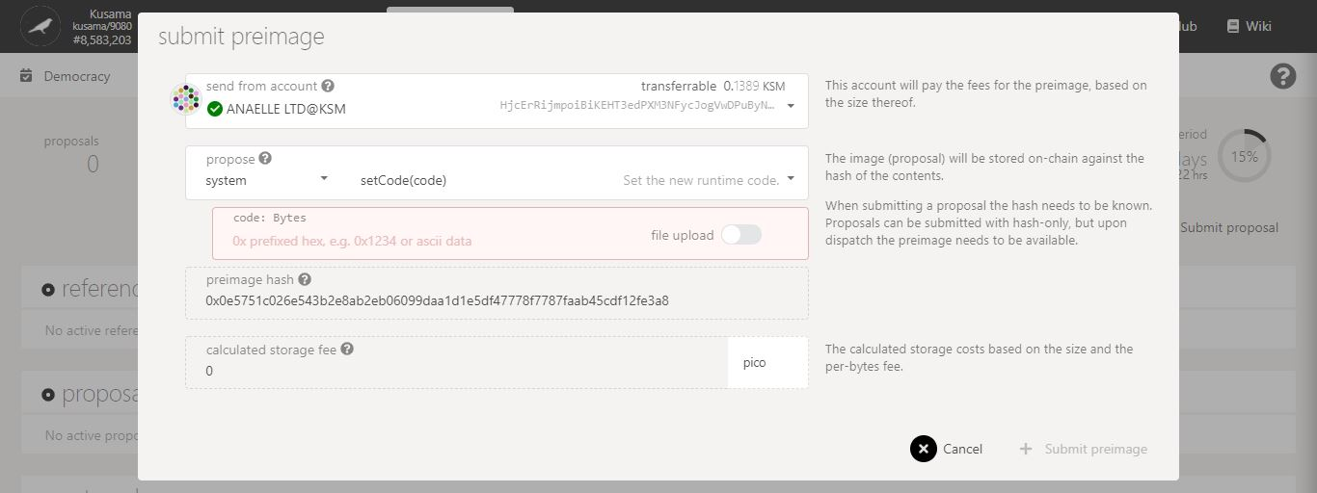

3. Click on the **dropdown arrow** to view the list of runtime modules.

2. Follow **on-screen instructions** carefully.

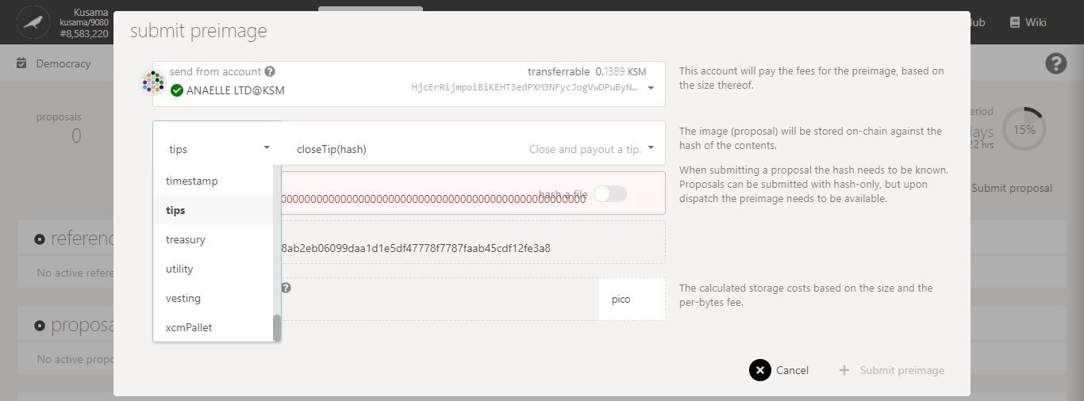

4. Select **the relevant module** for your preimage.

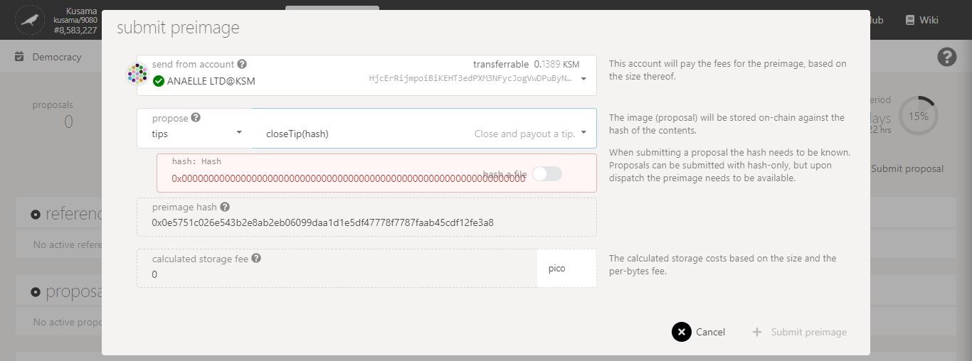

5. Click on the **dropdown arrow** to view the list of module methods.

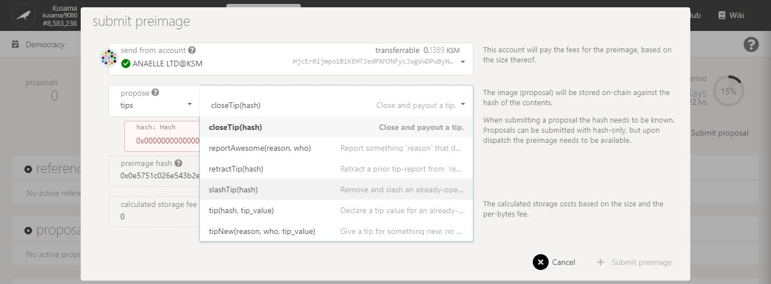

6. Select **the relevant method** for your preimage.

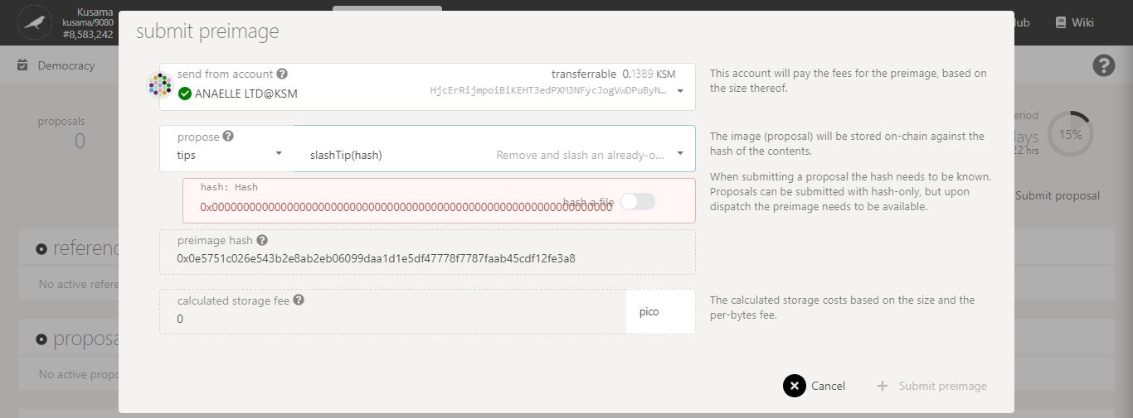

7. Switch **the button ON** to store a file relevant to your preimage on-chain.

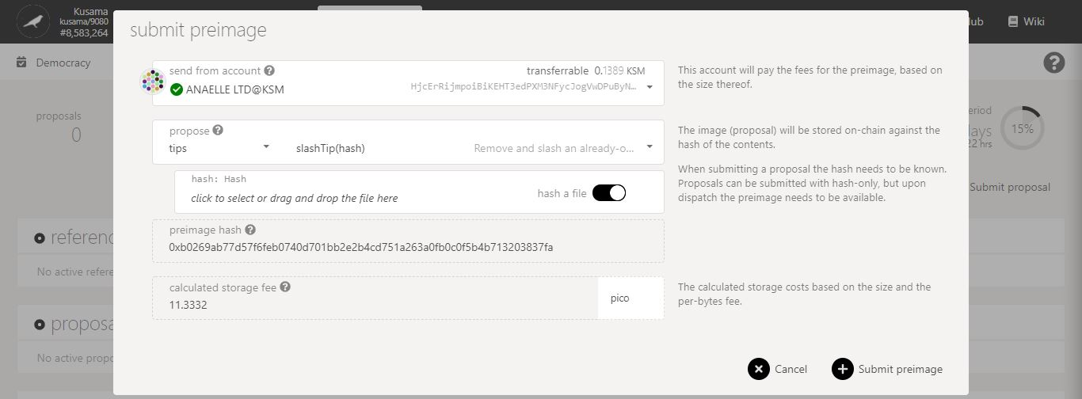

8. Click to **attach a file** to your preimage.

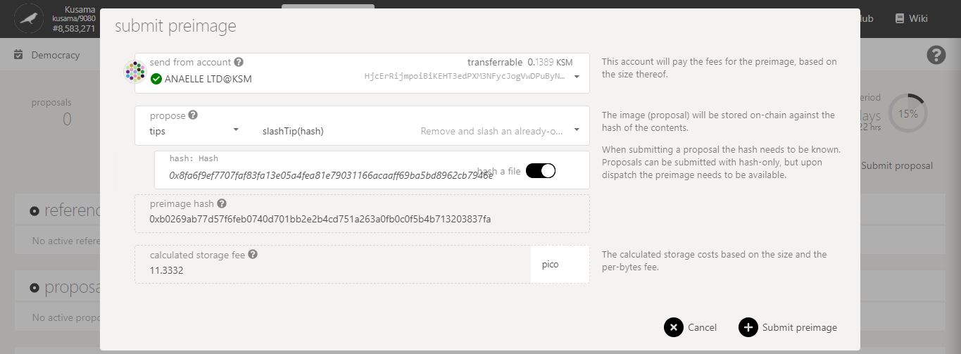

10. Check the **storage fees**.

9. **Your file has been hashed and is ready to be stored on-chain!**

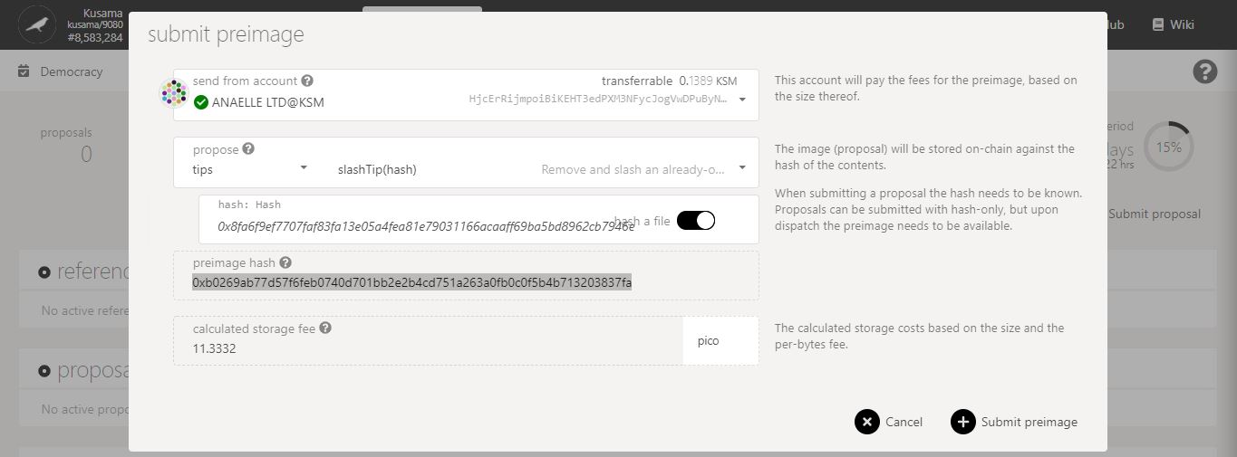

11. **Note down the preimage hash** for later use.

**Nature** of the transaction.

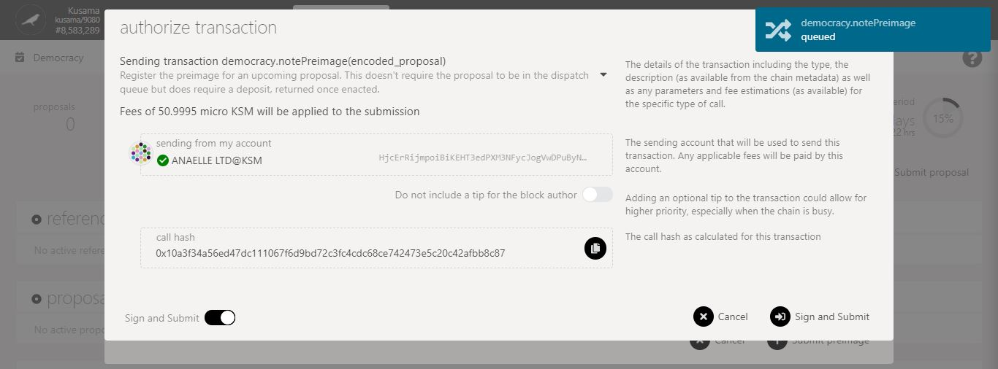

13. Click on **Sign & submit** to continue the procedure.

12. Check the **transaction fees**.

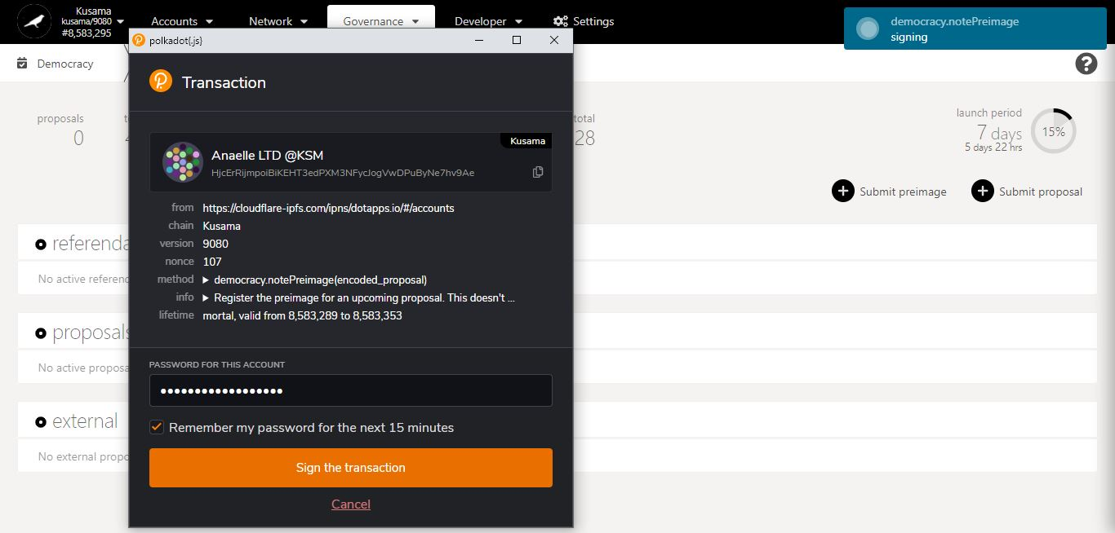

**Progress** of the transaction.

15. Click on **Sign the transaction** to complete the procedure.

14. Enter **your account’s password** and tick the box to **remember your password, if necessary**.

**Summary** of the transaction sent via the Polkadot-JS extension.

* 1. **Submit referendum proposals.**

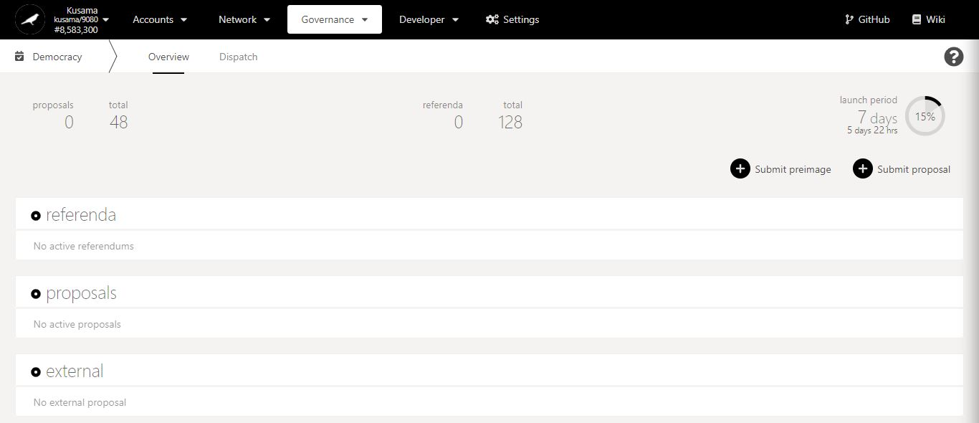

Referendum proposal in detail:

A **referendum proposal** is the second of two steps when proposing a public referendum that the community can vote on.

A minimum deposit is required to submit a proposal, but it will be released when the proposal is timetabled as a public referendum.

1. Click on **Submit proposal.**

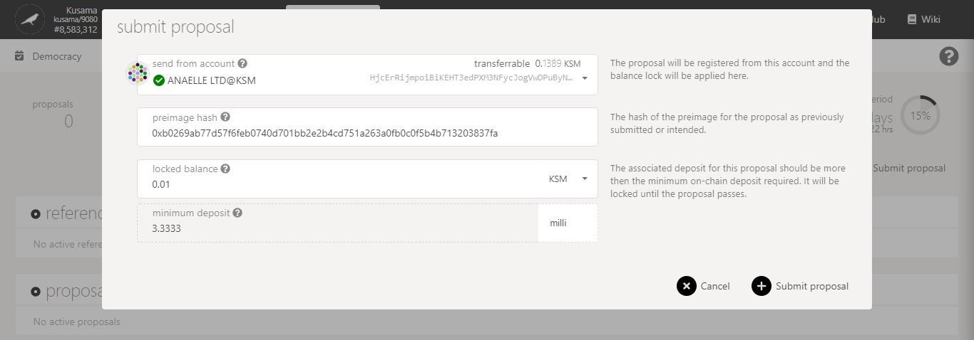

4. Check that you can afford **the minimum deposit.**

3. Enter the **required information**.

5. Click on **Submit proposal** to continue the procedure.

2. Follow **on-screen instructions** carefully.

**Nature** of the transaction.

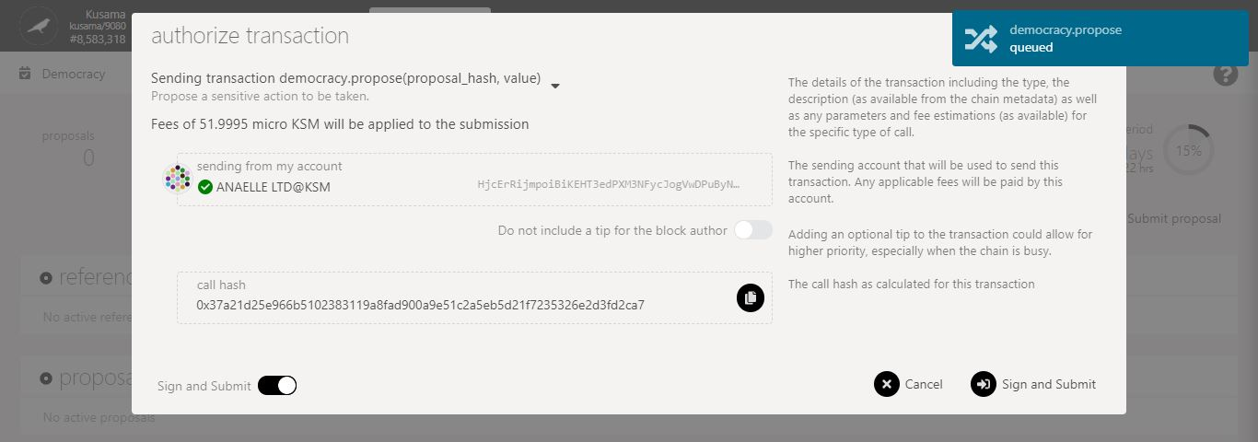

7. Click on **Sign & submit** to continue the procedure.

6. Check the **transaction fees**.

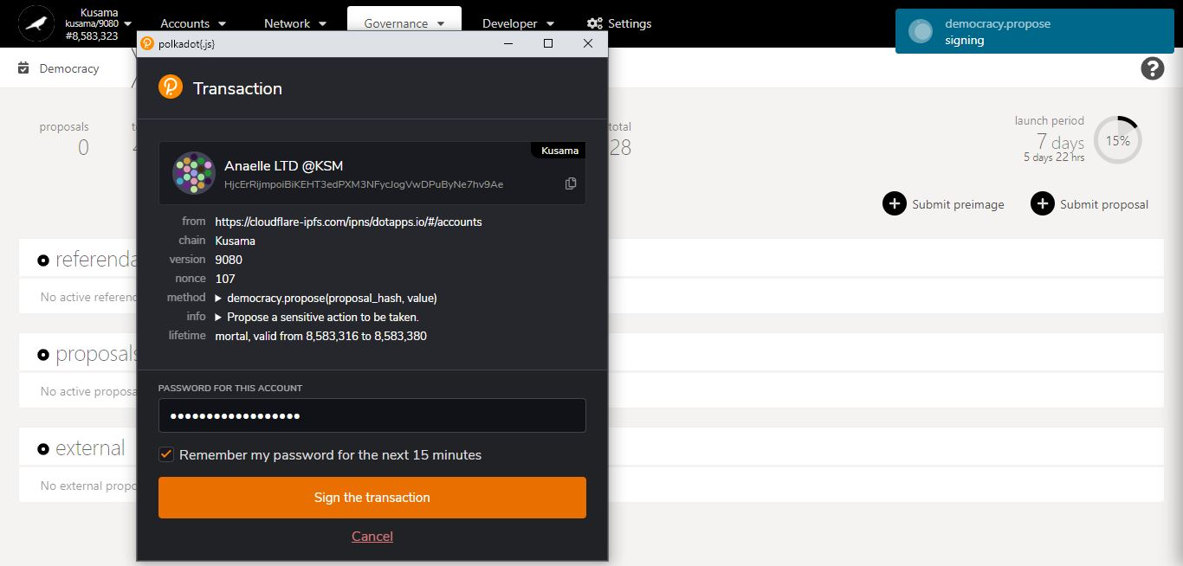

**Progress** of the transaction.

**Summary** of the transaction sent via the Polkadot-JS extension.

8. Enter **your account’s password** and tick the box to **remember your password, if necessary**.

9. Click on **Sign the transaction** to complete the procedure.

1. **Council: Explore council-related activities.**



* 1. **Vote for council members, runners up and candidates.**

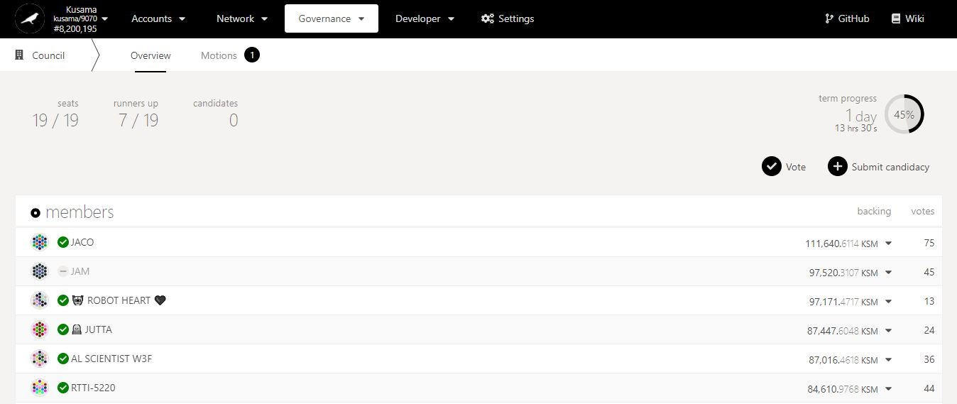

Council in detail:

The **council** is the on-chain account of a group of network participants that are elected for 1 term (i.e 1 day).

The council overlooks **referendum proposals, treasury proposals, tips, bounties, and technical committee memberships**.

Any KSM holder can vote for registered councillors/runners up/candidates. A voting deposit of 0.0675KSM is required, but it will be refunded once the vote is cleared.

1. Click on **vote**.

Key information on council: **number of seats, runners up, candidates, and countdown to new term.**

Cumulative **vote value** received by each councillor/runner up.

Councillor **identity/account address.**

**NEVER SEND YOUR KSM TO A COUNCILLOR’S ADDRESS!**

Number of **votes** received by each councillor/runner up.

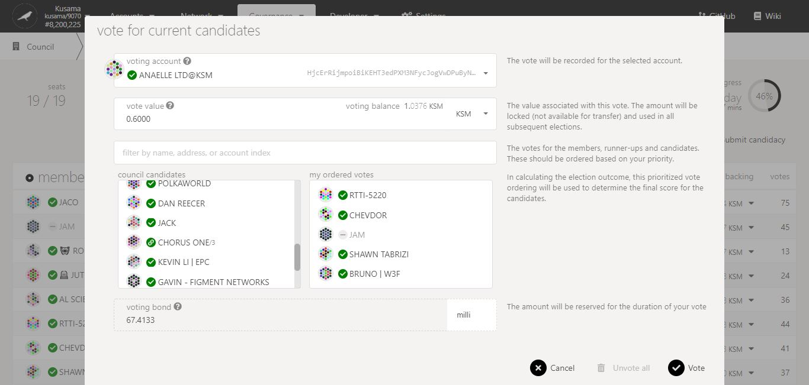

5. Click on **Vote** to continue the procedure.

4. Click on **1-16** **candidates’ names** to order them in **your selection.**

3. Enter a KSM amount **for your vote.**

2. Follow **on-screen instructions** carefully.

**Nature** of the transaction.

7. Click on **Sign & submit** to continue the procedure.

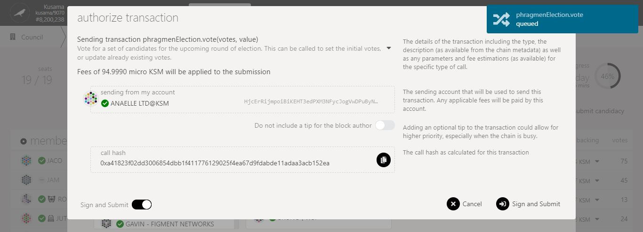

6. Check the **transaction fees**.

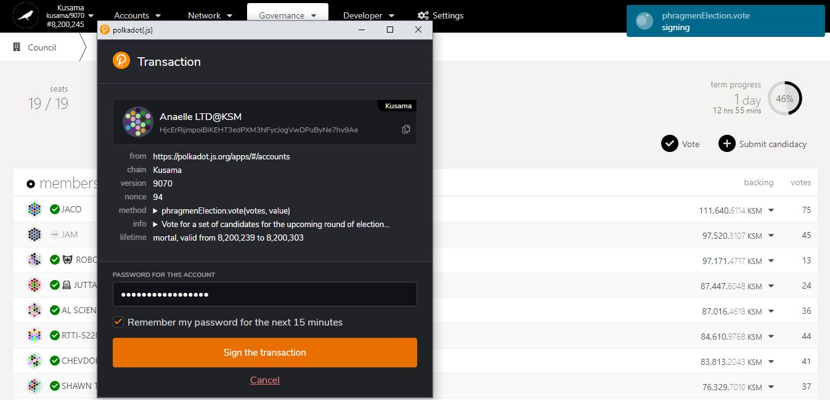

9. Click on **Sign the transaction** to complete the procedure.

**Summary** of the transaction sent via the Polkadot-JS extension.

**Progress** of the transaction.

8. Enter **your account’s password** and tick the box to **remember your password, if necessary**.

* 1. **Clear council election votes.**

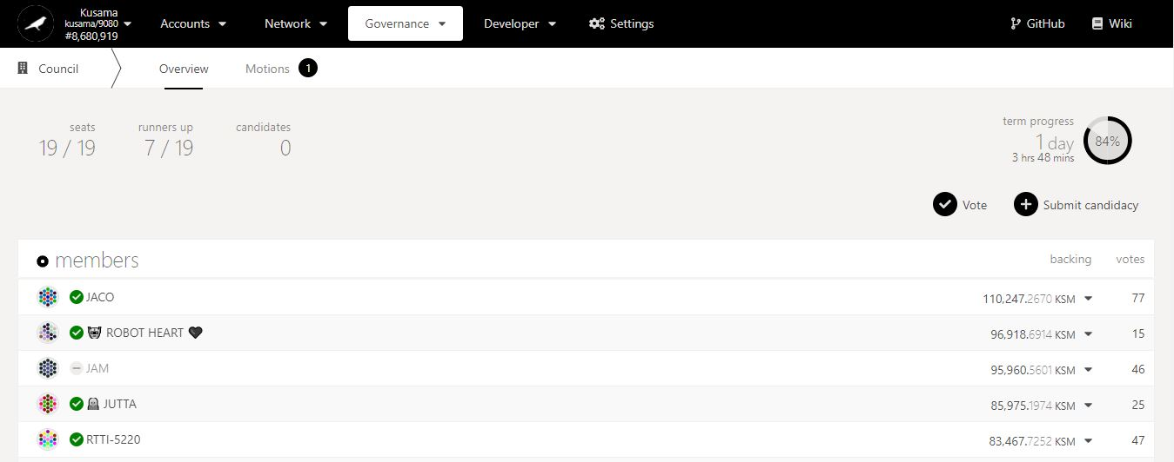

1. Click on **vote**.

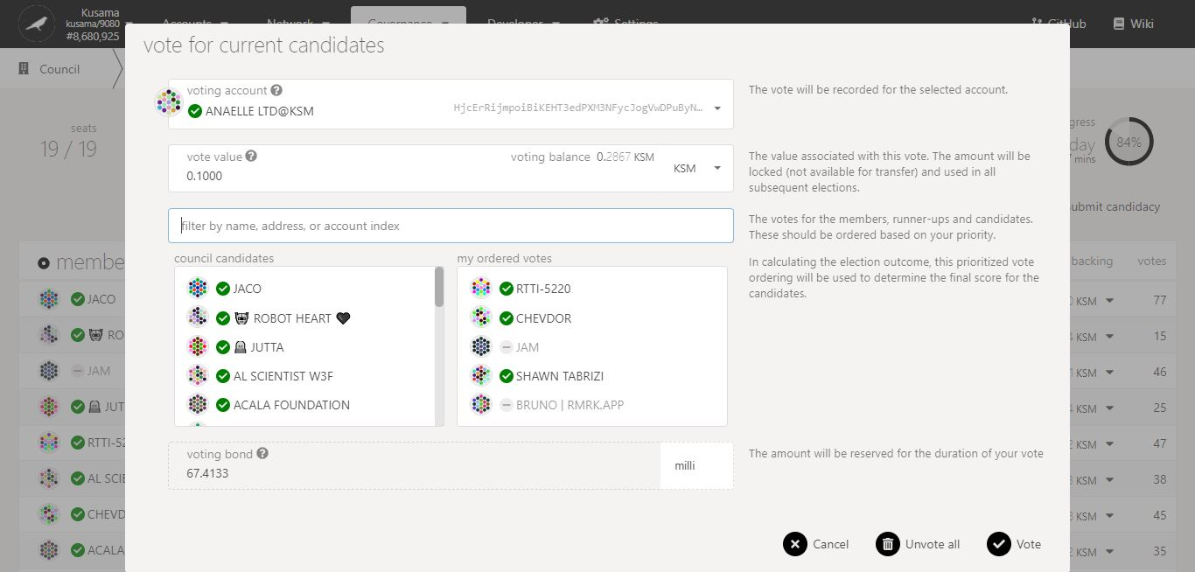

2. Click on **Unvote all** to continue the procedure.

**Nature** of the transaction.

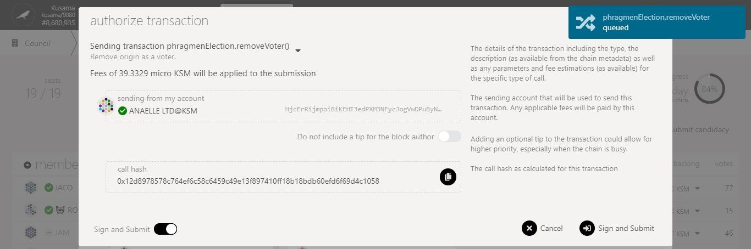

4. Click on **Sign & submit** to continue the procedure.

3. Check the **transaction fees**.

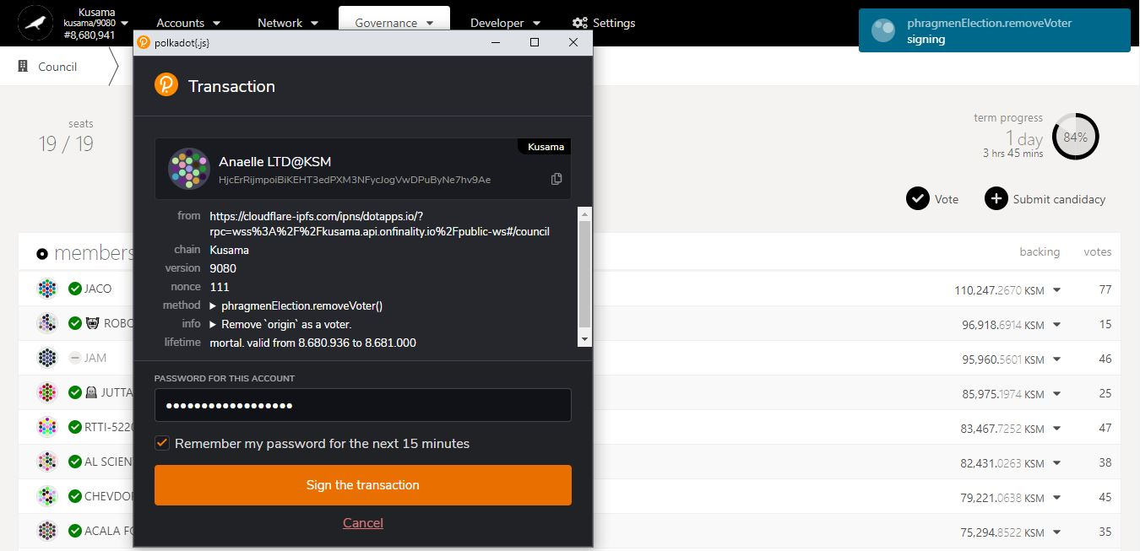

**Summary** of the transaction sent via the Polkadot-JS extension.

5. Enter **your account’s password** and tick the box to **remember your password, if necessary**.

6. Click on **Sign the transaction** to complete the procedure.

**Progress** of the transaction.

* 1. **Submit a candidacy for council.**

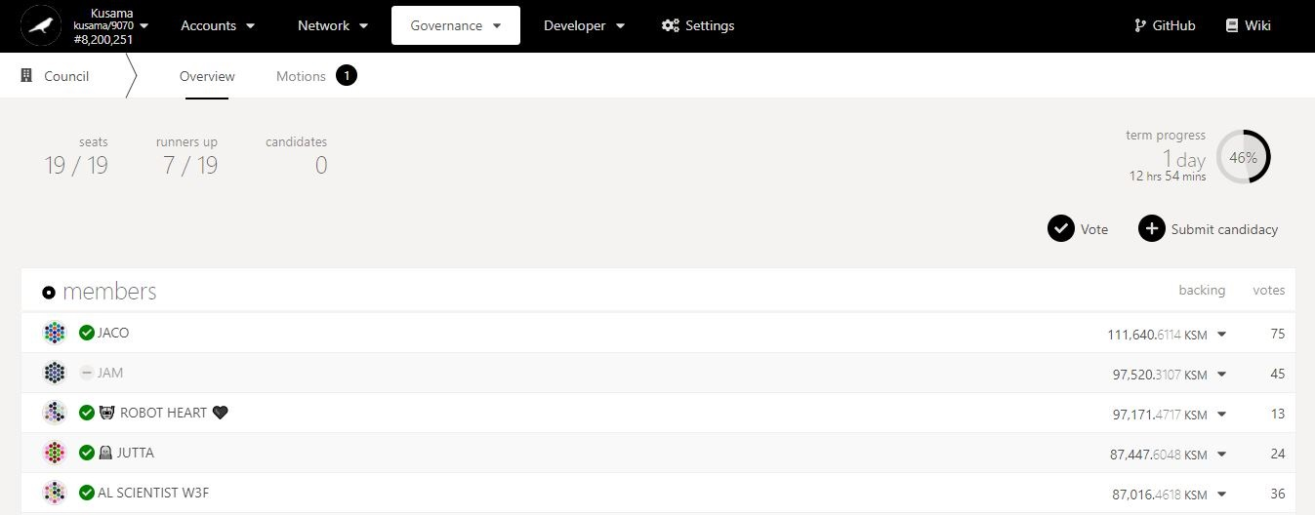

Council candidacy in detail:

A **council candidacy** is used to run **a campaign for election** as one of the 19 councillors or 19 runners up.

Any KSM holder can register to become a councillor/runner up and vote for him/herself. A candidacy deposit of 0.0034KSM is required and will be refunded once the candidacy is cleared.

1. Click on **Submit candidacy**.

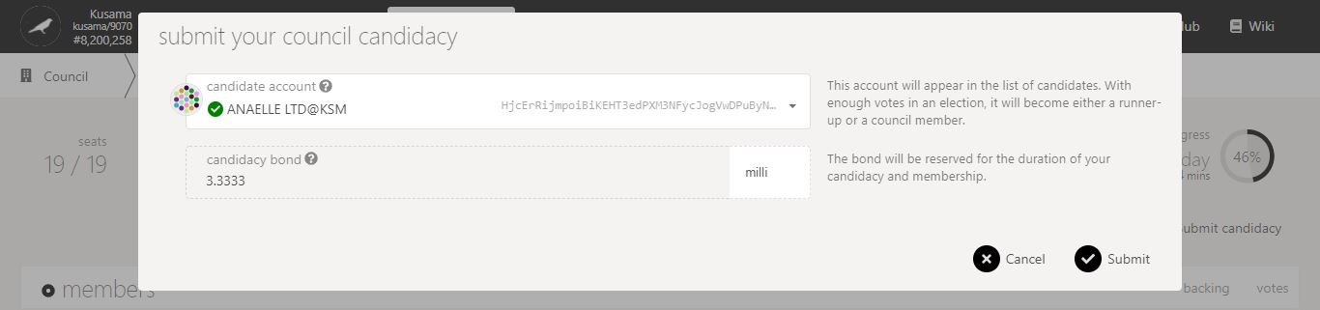

3. Click on **Submit** to continue the procedure.

2. Follow **on-screen instructions** carefully.

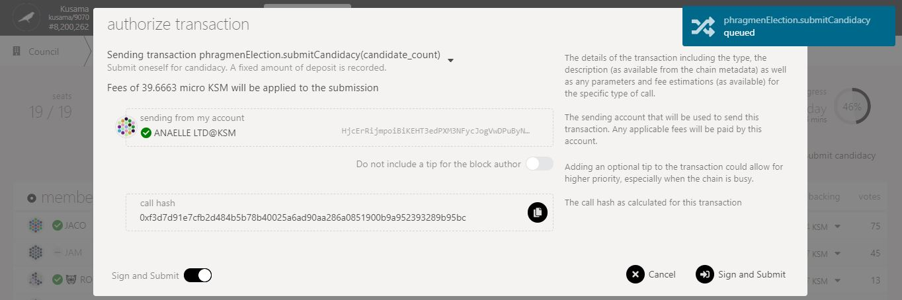

5. Click on **Sign & submit** to continue the procedure.

4. Check the **transaction fees**.

**Nature** of the transaction.

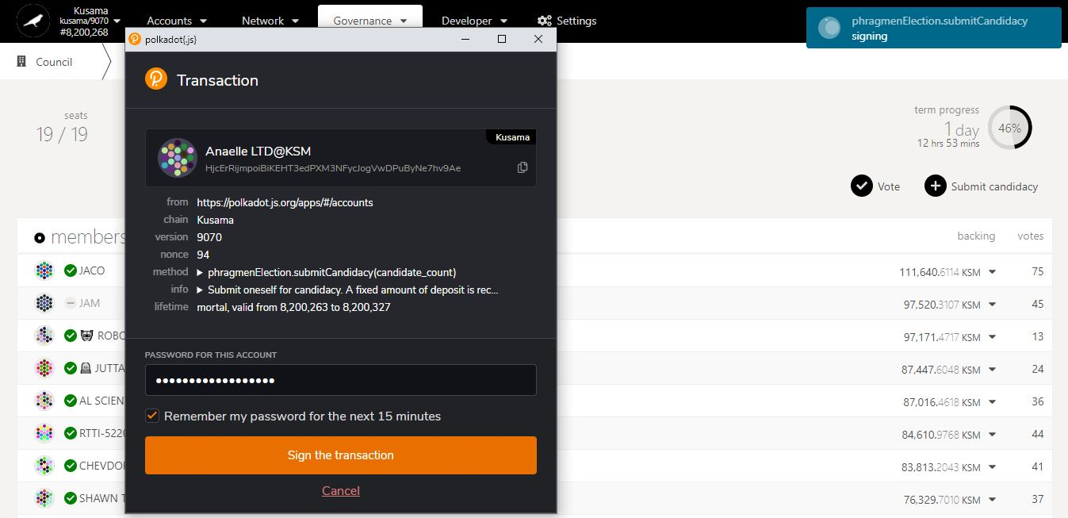

**Progress** of the transaction.

**Summary** of the transaction sent via the Polkadot-JS extension.

6. Enter **your account’s password** and tick the box to **remember your password, if necessary**.

7. Click on **Sign the transaction** to complete the procedure.

* 1. **View council motions.**

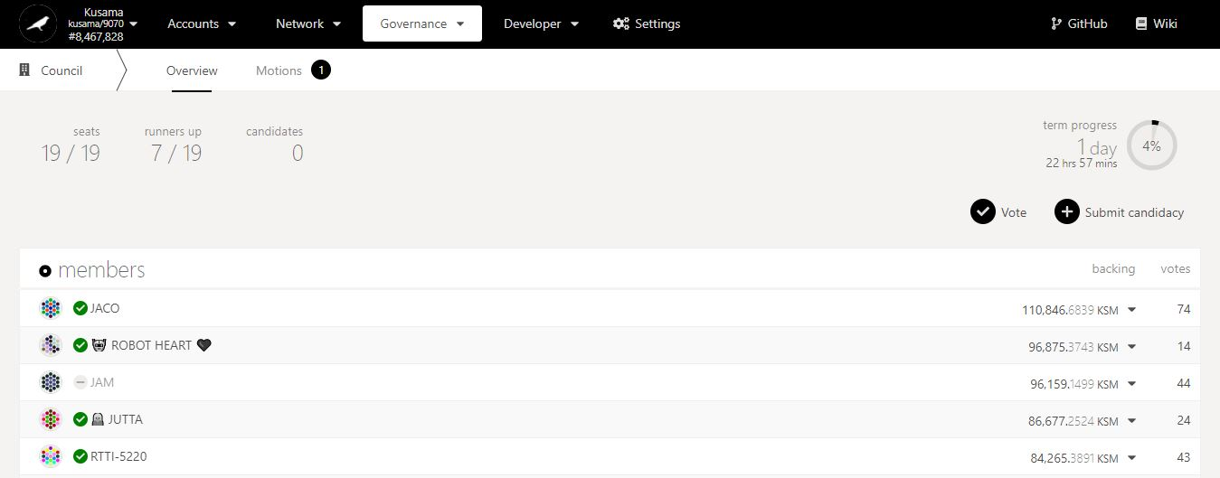

1. Click on **Motions.**

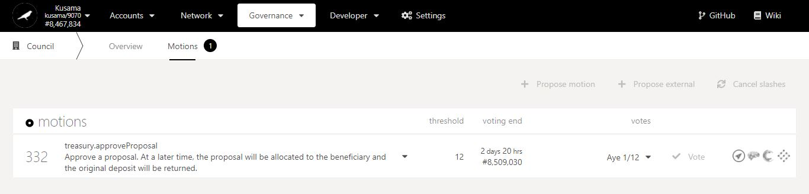

Key information on motions: **proposal ID, nature of the proposal, voting minima for approval, and time left to approve/reject.**

1. Click on the **dropdown arrow** to view the motion in detail.

Motion-related **external links**.

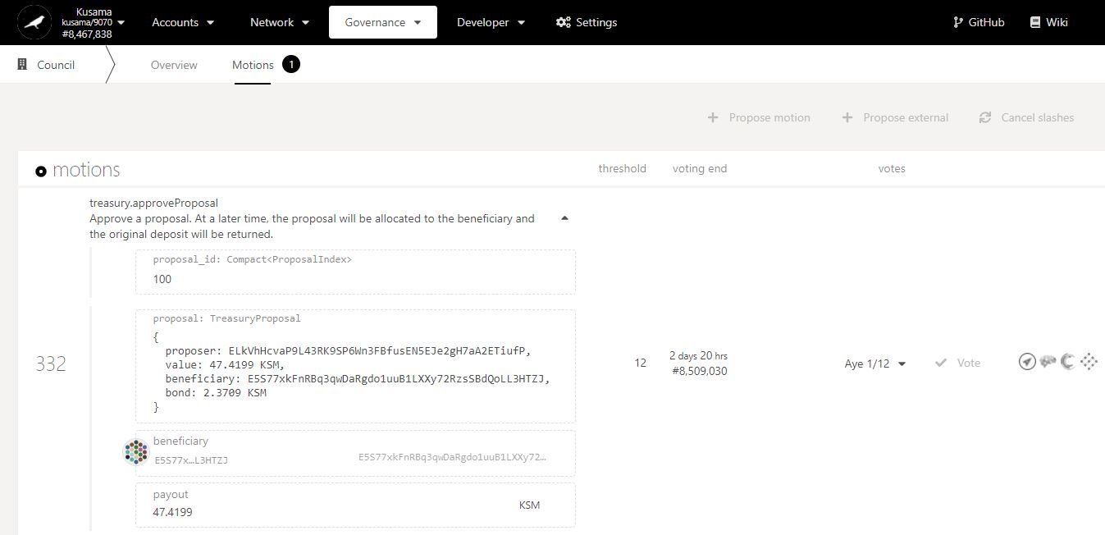

2. Click on the **dropdown arrow** to view current votes in detail.

Motion in detail:

A **motion** is a vote created by the council to **approve or reject** referendum/treasury/bounty proposals.

It summarises information on the proposals (nature, proposer, value, bond paid, etc) that are stored on-chain.

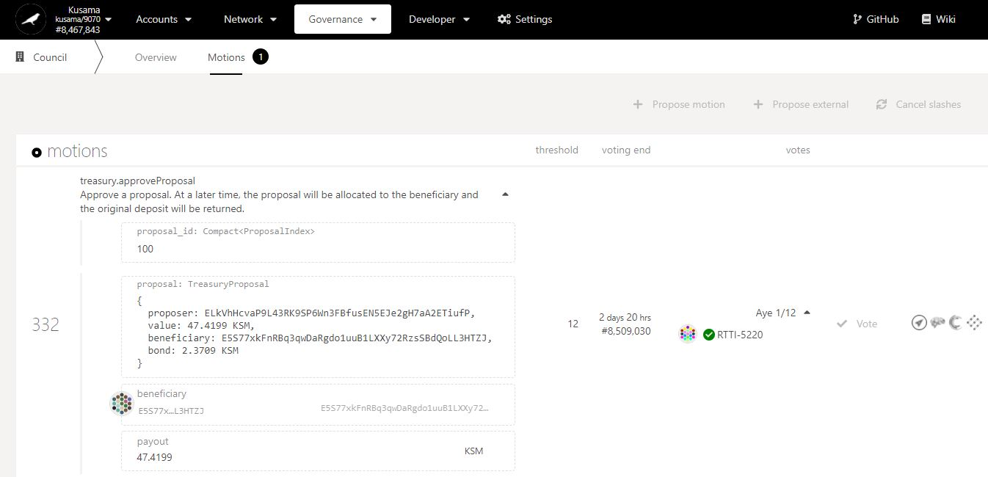

3. Click on the ***Polkassembly* icon** to view the discussion thread.

Identity of the **approving councillor(s).**

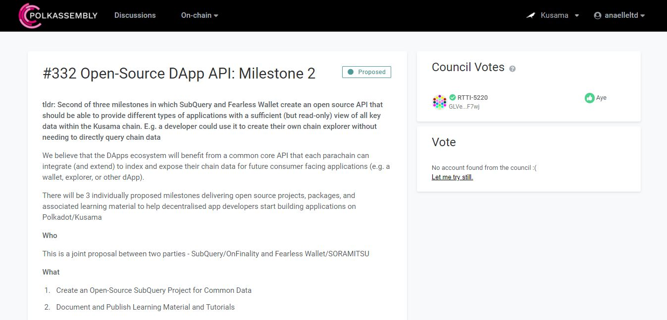

4. Read the **information on the treasury proposal**.

1. **Treasury: Explore treasury-related activities.**



**Basic information on technical words** used in the TREASURY section.

* 1. **View and submit treasury proposals.**

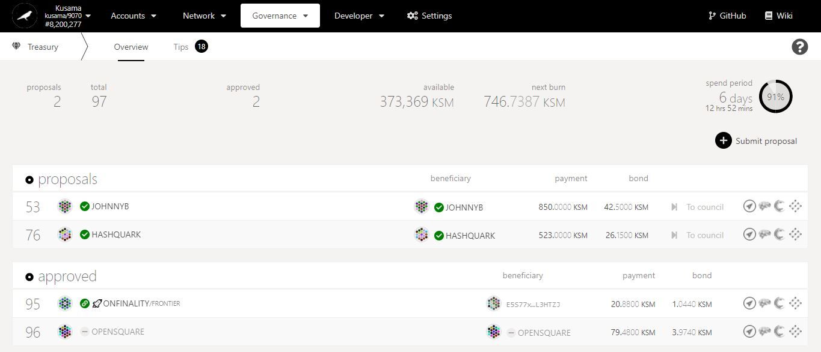

Treasury proposal in detail:

A **treasury proposal** is used to request funds from the Treasury pot.

The proposer needs to submit details of the proposal (i.e problem statement, proposed solutions, payout requested, milestones, etc) on **a public forum** for discussion.

A proposal bond of at least 5% of the requested payout is required and will only be refunded if the proposal is approved.

1. Click on **Submit proposal**.

Proposal-related **external links**.

Key information on treasury: **number of active & approved proposals, current pot & next burn amounts, time left before the next burn.**

Proposer’s **Identity.**

**Payout requested** for the proposal and **deposit paid** by the proposer.

Beneficiary’s **account address.**

Proposal **ID.**

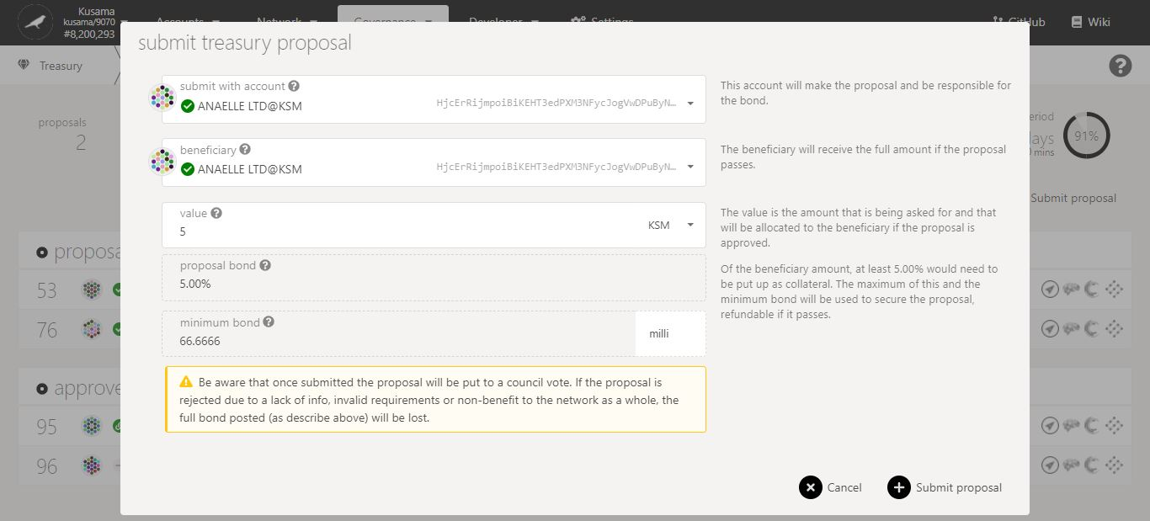

4. Click on **Submit proposal** to continue the procedure.

3. Double-check **warning messages.**

2. Follow **on-screen instructions** carefully.

**Nature** of the transaction.

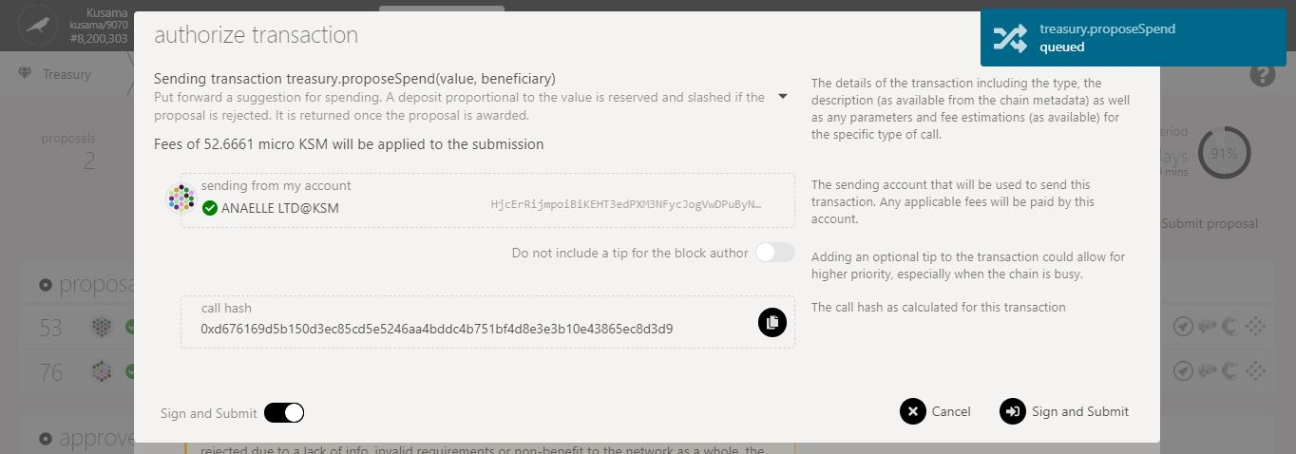

6. Click on **Sign & submit** to continue the procedure.

5. Check the **transaction fees**.

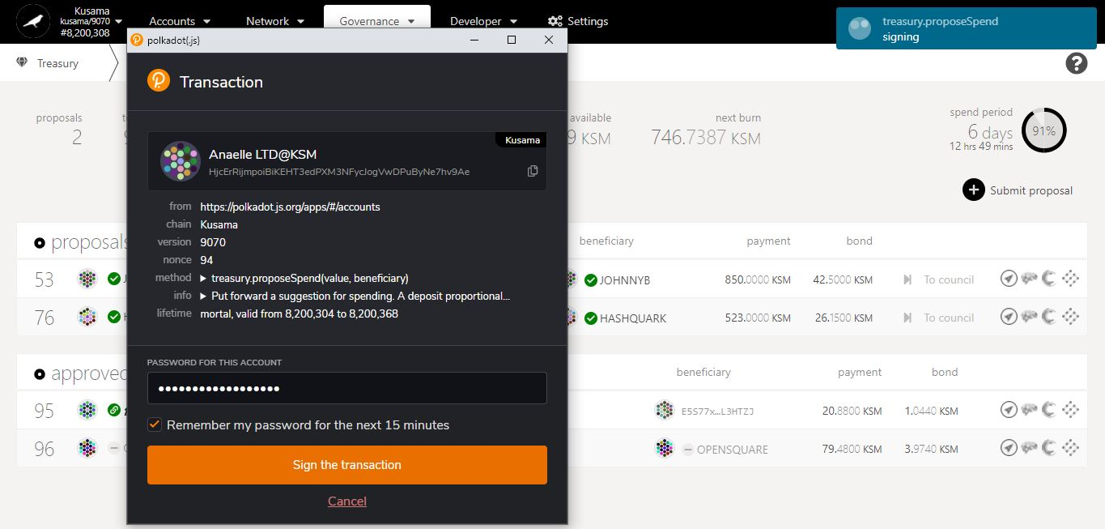

**Progress** of the transaction.

**Summary** of the transaction sent via the Polkadot-JS extension.

7. Enter **your account’s password** and tick the box to **remember your password, if necessary**.

8. Click on **Sign the transaction** to complete the procedure.

* 1. **View and submit treasury tips.**

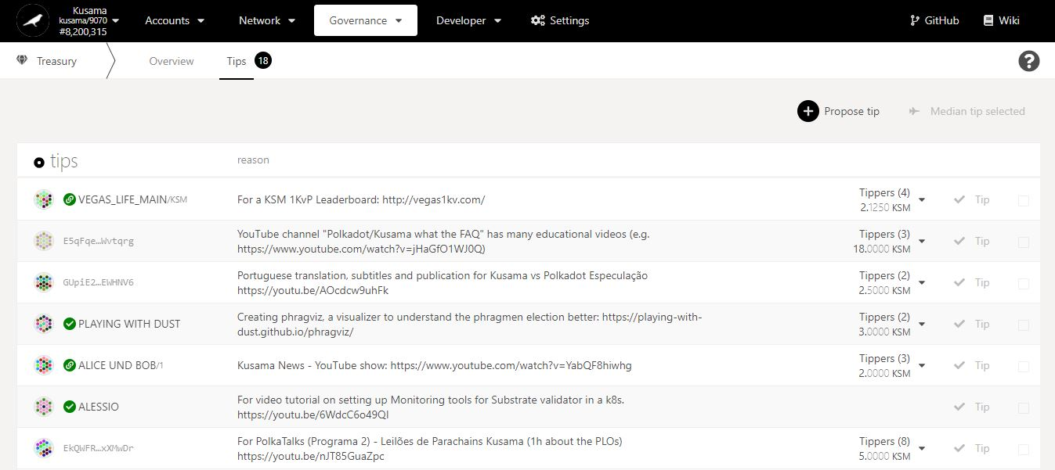

Key information on tips: **number of opened tips, current proposers, reasons for tips, and proposed tip payouts.**

Treasury tips in detail:

A **treasury tip** is used to request funds from the Treasury pot and can be submitted:

- by yourself and for yourself (i.e the account address of the proposer and the beneficiary are the same).

- on behalf of someone else (i.e the account address of the proposer and the beneficiary are different. The proposer will **earn a finder’s fee of 20% of the final tip amount**).

A tip deposit of about 0.0072KSM is required and will be refunded once the tip is closed.

Number of tippers and proposed **payout**.

1. Click on **Submit tip**.

Beneficiary’s **identity** or **account address.**

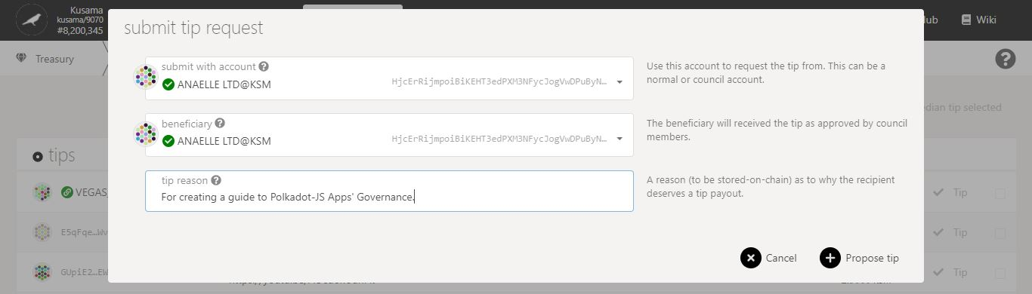

3. Click on **Propose tip** to continue the procedure.

2. Follow **on-screen instructions** carefully.

**Nature** of the transaction.

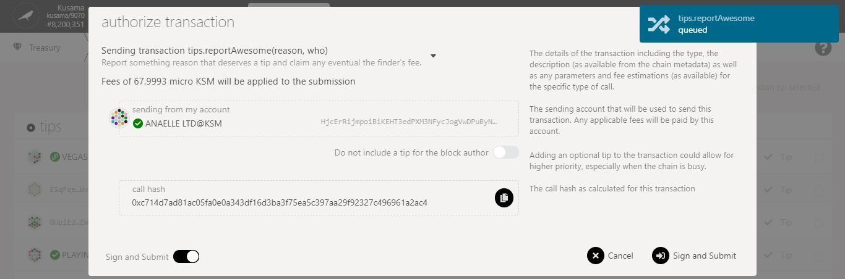

5. Click on **Sign & submit** to continue the procedure.

4. Check the **transaction fees**.

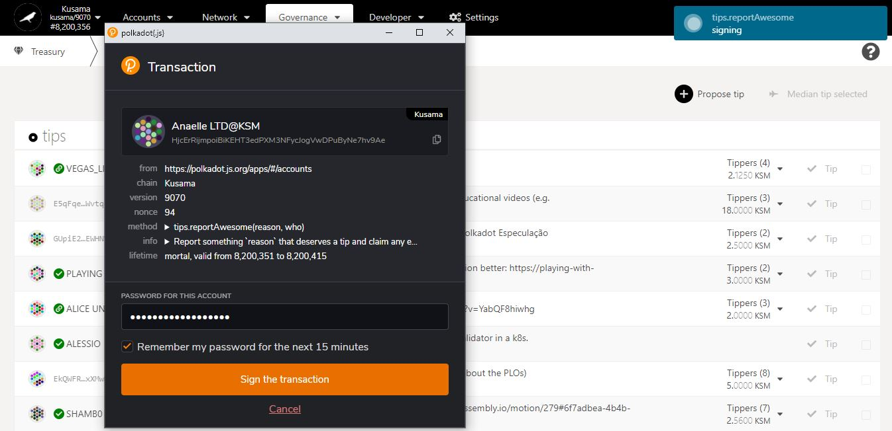

7. Click on **Sign the transaction** to complete the procedure.

**Progress** of the transaction.

**Summary** of the transaction sent via the Polkadot-JS extension.

6. Enter **your account’s password** and tick the box to **remember your password, if necessary**.

1. **Bounties: Explore bounty-related activities.**



* 1. **View active bounty proposals.**

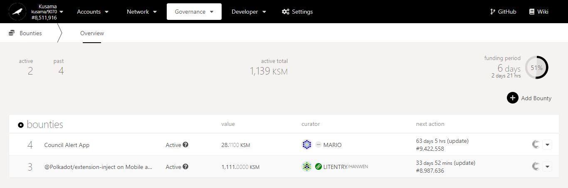

1. Click on the **dropdown arrow** for more details.

Key information on Bounties: **number of active & approved bounties, value of active bounties, countdown to next bounty spending period.**

Bounty-related **information**.

Countdown to the **next bounty milestone.**

Funding **status** & **amounts.** Note: Bounties are implemented over an extended period.

Bounty **title.**

Bounty **ID.**

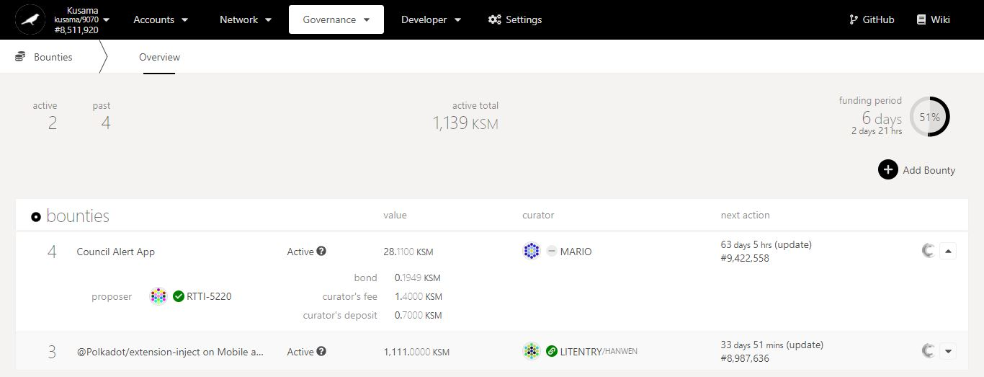

2. Click on the ***Polkassembly* icon** to view the discussion thread.

Bounty proposal in detail:

A **bounty proposal** is used by council members to delegate the supervision of treasury proposals to expert curators.

The proposer needs to submit details of the proposal (i.e payouts, milestones, etc) on a public forum and **select a curator after approval**.

A proposal bond and a curator’s deposit are both required and will only be refunded once all bounty milestones are completed.

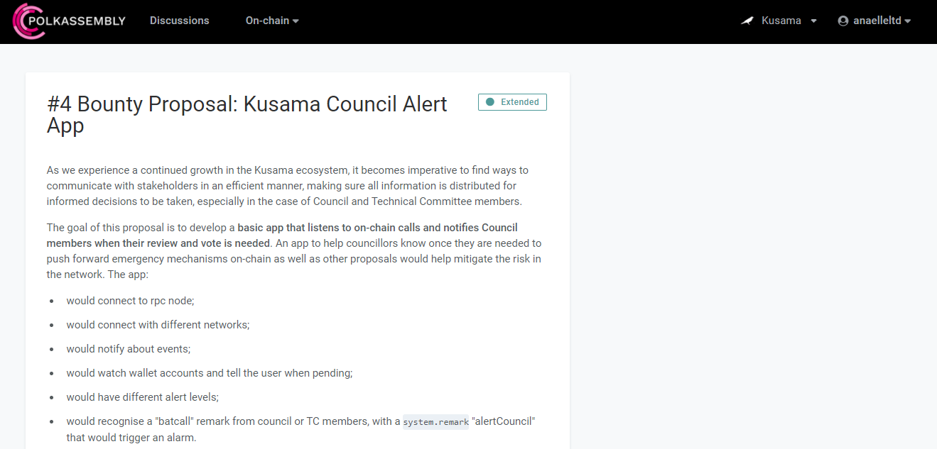

3. Read the **information on the treasury proposal**.

* 1. **Submit bounty proposals.**



1. Click on **Add bounty**.

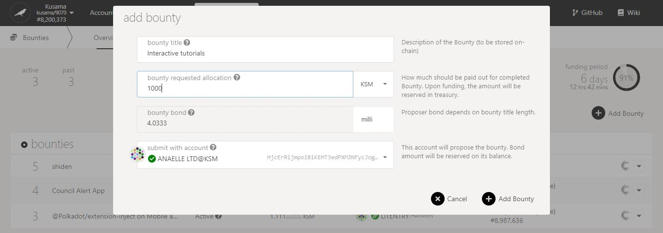

3. Click on **Add Bounty** to continue the procedure.

2. Follow **on-screen instructions** carefully.

**Nature** of the transaction.

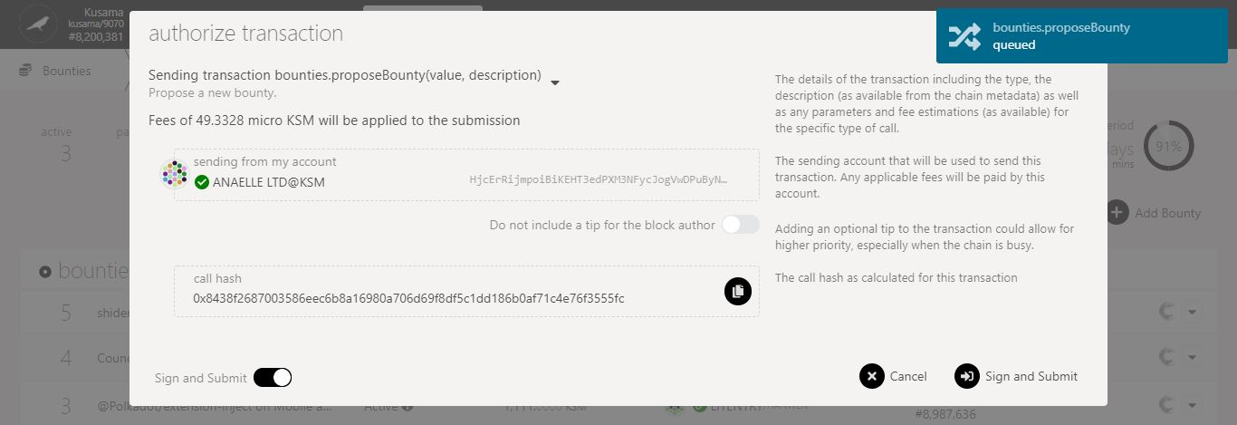

4. Check the **transaction fees**.

5. Click on **Sign & submit** to continue the procedure.

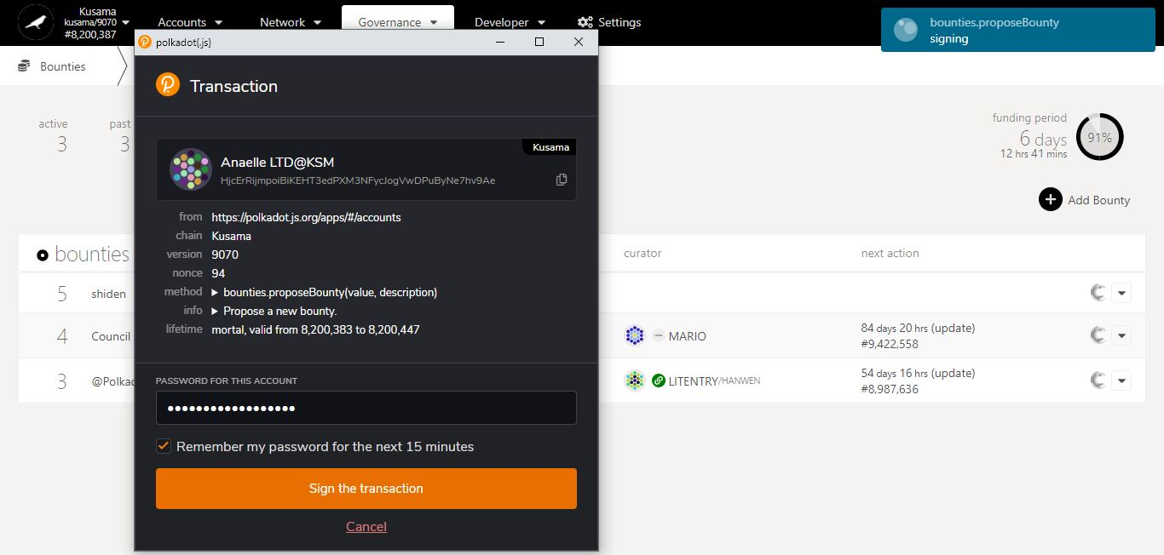

7. Click on **Sign the transaction** to complete the procedure.

**Progress** of the transaction.

6. Enter **your account’s password** and tick the box to **remember your password, if necessary**.

**Summary** of the transaction sent via the Polkadot-JS extension.

1. **Technical Committee: Explore technical committee-related activities.**



* 1. **View technical committee members.**

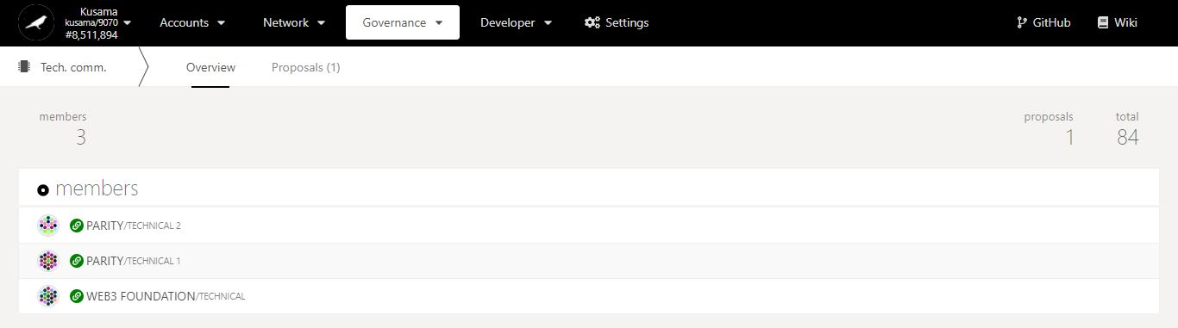

Technical committee in detail:

**Technical committee members** are chosen within teams that are actively developing **Relay chains runtime implementations**.

They are installed by the Council.

Key information on Tech committee: **members, number of active & approved proposals.**

* 1. **View active technical committee proposals.**

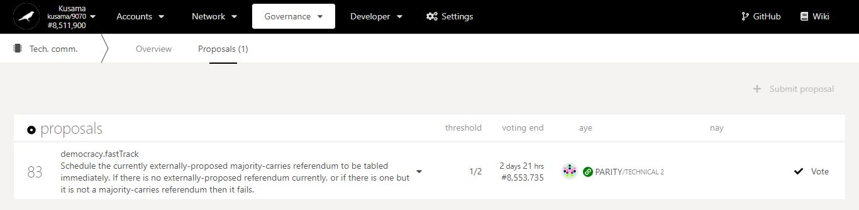

Key information on TC proposals: **proposal ID, nature of the proposal, proposer, and time left to approve/reject.**

1. Click on the **dropdown arrow** to view the proposal in detail.

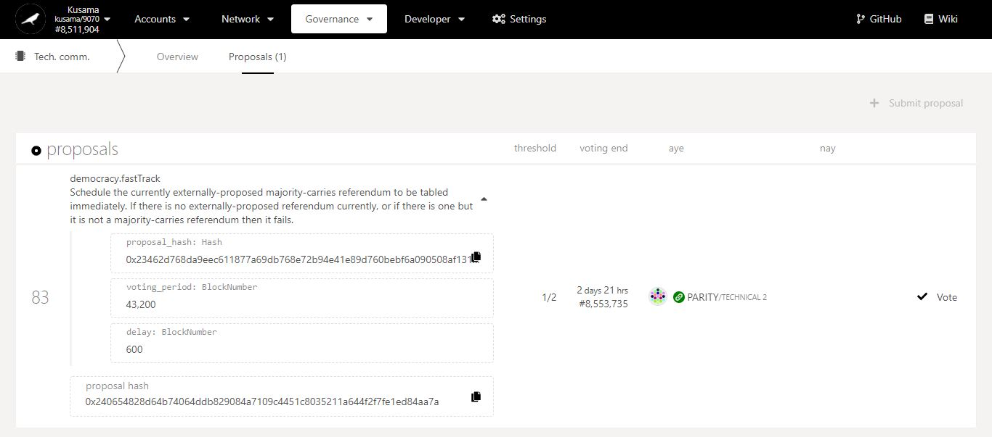

TC proposal in detail:

A **TC proposal** isused to schedule emergency referenda for bug fixes and **fast-track runtime upgrades**.